1)DATA SCHEMA

🡪defines how data is organized within a relational database.

🡪A database schema is the logical representation of a database, which shows how the data is stored logically in the entire database.

🡪The schema does not physically contain the data itself; instead, it gives information about the shape of data and how it can be related to other tables or models.

2)DATABASE

🡪A database is a place to store information.

🡪The database stores the information in a well-structured format.

3)TYPES OF DATABASE SCHEMA

1. Logical Schema
2. Physical Schema
3. View Schema

4)PHYSICAL DATABASE SCHEMA

🡪A physical database schema specifies how the data is stored physically on a storage system or disk storage in the form of Files and Indices.

5)LOGICAL DATABASE SCHEMA

🡪The Logical database schema specifies all the logical constraints that need to be applied to the stored data.

🡪Defines the views, integrity constraints, and table.

🡪 the term integrity constraints define the set of rules that are used by DBMS (Database Management System) to maintain the quality for insertion & update the data.

🡪Many tools are used to create a logical database schema, and these tools demonstrate the relationships between the component of your data; this process is called ERmodelling.

🡪The ER modelling stands for entity-relationship modelling, which specifies the relationships between different entities.

6)PRIMARY KEY

🡪primarykeyis used to uniquely identify the entry in a document or record. The Ids of the upper three circles are the primary keys.

7)FOREIGN KEY

🡪Foreignkey is used as the primary key for other tables. The FK represent the foreign key in the diagram. It relates one table to another table.

8)VIEW SCHEMA

🡪 View level design of a database is known as viewschema. This schema generally describes the end-user interaction with the database systems.

9)DATABASE SCHEMA DESIGNS

* 1. Flat Model
  2. Hierarchical Model
  3. Network Model
  4. Relational Model
  5. Star Schema
  6. Snowflake Schema

9)FLAT MODEL

🡪A flat model schema is a type of 2-D array in which each column contains the same type of data, and elements within a row are related to each other.

10)HIERARCHIAL MODEL

🡪The Hierarchical model design contains a tree-like structure. The tree structure contains the root node of data and its child nodes.

11)NETWORK MODEL

🡪The network model design is similar to hierarchical design as it represents a series of nodes and vertices.

🡪The main difference between the network model and the hierarchical model is that the network model allows a many-to-many relationship. In contrast, the hierarchical model only allows a one-to-many relationship.

12)RELATIONAL MODEL

🡪The relational models are used for the relational database, which stores data as relations of the table.

13)STAR SCHEMA

🡪It is best suitable for storing and analysing a huge amount of data, and it works on "Facts" and "Dimensions".

14)SNOWFLAKE SCHEMA

🡪In snowflake, dimension tables can have their own dimension tables.

15)CO-RELATED SUBQUERIES

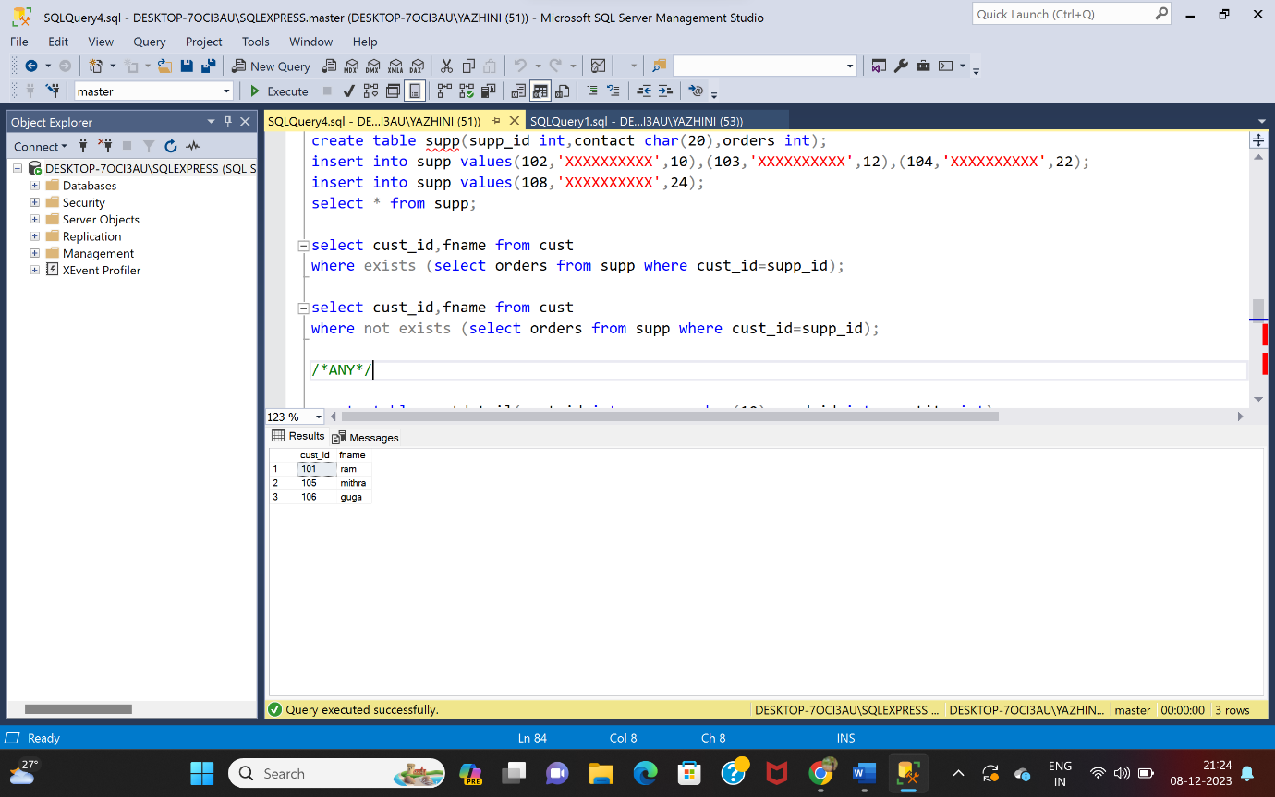

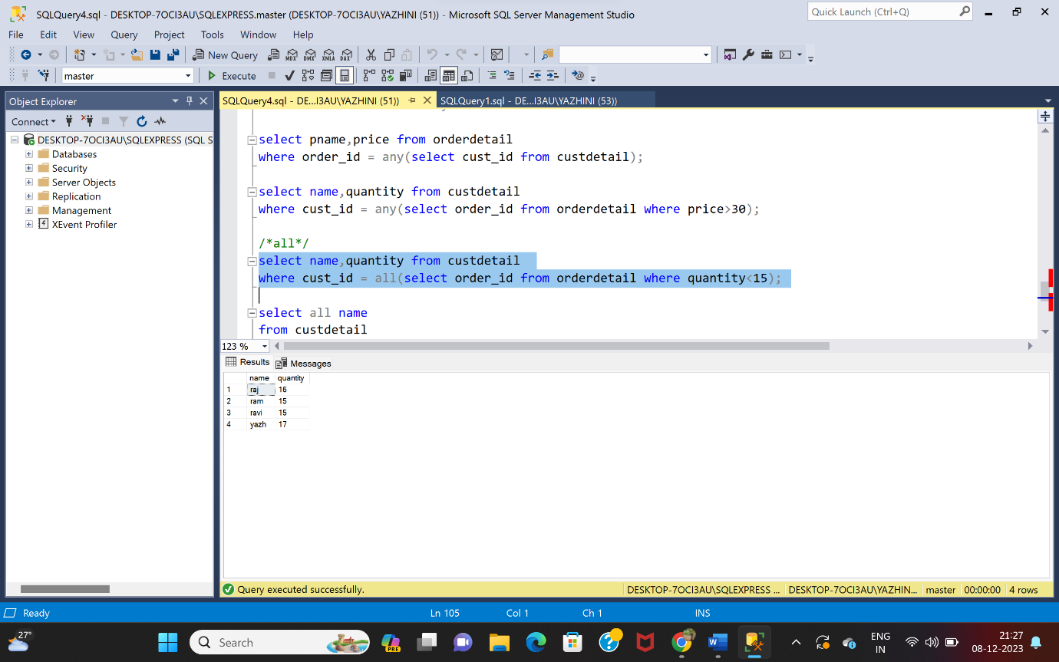

16)ROLLUP

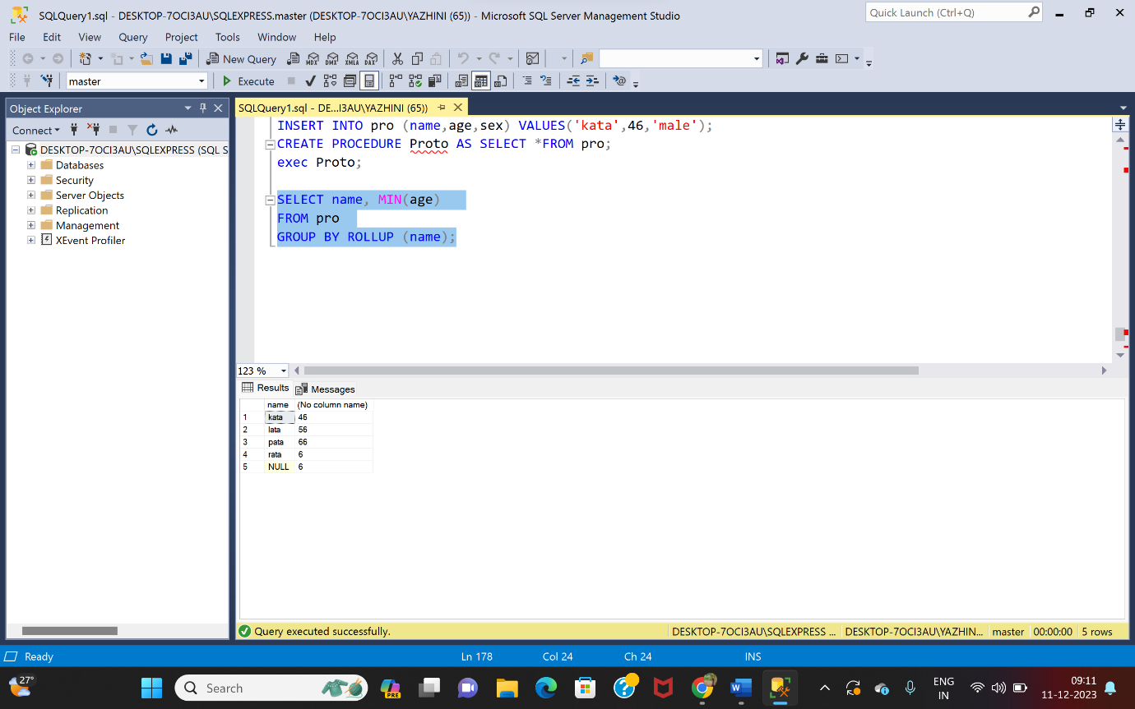

17)PROCEDURE

